**Gurugram Global College of Pharmacy**



**PRACTICAL LAB MANUAL**

**Physical Pharmaceutics - II**

**B. Pharm IVth Semester**

|  |  |  |
| --- | --- | --- |
|  | **VISION & MISSION OF INSTITUTE** | **SESSION: 2024-25 SEM: IV**  **SUB CODE: BP403T** |

**VISION OF INSTITUTE**

Our vision is to improvise health through innovation and leadership in pharmacy education, research and clinical practice and to transform healthcare to create positive patient outcomes.

Our core values emphasize:

1.To provide quality of education to student of pharmaceutical sciences at all academic levels, using best practices and evidence-based educational approaches, which enable our graduates to advance their profession.

2.To provide an academic environment that promotes effective mentoring, professional growth and development.

3. To be a prestigious college that advances basic, clinical and translational research 4. To meet and improve society’s health wellness and health care

5.Lead innovative research in pharmaceutical sciences and patient care through embracing the value of interdisciplinary work.

**MISSION OF INSTITUTE**

Our mission is to develop pharmacists, educators and researchers whose leadership dedication and innovation improvise the health of our local and global communities.

-To provide excellent education in a stimulating environment where knowledge of basic subjects is integrated with health concerns for the world community.

-The program teaches professional ethics, social responsibility and commitment of lifelong learning.

-It imparts skill to work in industry, clinical set ups, drug control organization, education and research in pharmaceutical field.

|  |  |  |
| --- | --- | --- |
|  | **PROGRAM OUTCOMES** | **SESSION: 2024-25 SEM: IV**  **SUB CODE: BP403T** |

**PROGRAM OUTCOMES**

Pharmacist Graduates will be able to:

**PO1. Health science knowledge:** Apply the knowledge of science, health sector

fundamentals, and specialization to the solution of multifaceted problems.

**PO2. Problem analysis**: Identify, formulate, review research literature, and analyze problems reaching substantiated conclusions using principles of life, applied, and, natural sciences.

**PO3. Design/development of solutions**: Design solutions for unresolved issues and design system components or processes that meet the specified needs with appropriate consideration for the public health and safety, and the cultural, societal, and environmental considerations.

**PO4. Conduct investigations of complex problems**: Use research-based knowledge and research methods including design of experiments, analysis and interpretation of data, and synthesis of the information to provide valid conclusions.

**PO5. Modern tool usage**: Create, select, and apply appropriate techniques, resources, and modern tools and techniques including prediction and modeling to numerous activities with an understanding of the limitations.

**PO6. The pharmacist and society**: Apply reasoning informed by the contextual knowledge to assess societal, health, safety, legal and cultural issues and the consequent responsibilities relevant to the professional practices.

**PO7. Environment and sustainability**: Understand the impact of the professional engineering solutions in societal and environmental contexts, and demonstrate the knowledge of, and need for sustainable development.

**PO8. Ethics**: Apply ethical principles and commit to professional ethics and responsibilities and norms of the pharmaceutical practice.

**PO9. Individual and teamwork**: Function effectively as an individual, and as a member or leader in diverse teams, and in multidisciplinary settings.

**PO10. Communication**: Communicate effectively on multifaceted activities with the

community and with society at large, such as, being able to comprehend and write effective reports and design documentation, make effective presentations, and give and receive clear instructions.

**PO11. Project management and finance**: Demonstrate knowledge and understanding of the management principles and apply these to one’s own work, as a member and leader in a team, to manage projects and in multidisciplinary environments.

**PO12. Life-long learning**: Recognize the need for and have the preparation and ability to engage in independent and life-long learning in the broadest context of technological chang

|  |  |  |
| --- | --- | --- |
|  | **COURSE OUTCOMES** | **SESSION: 2024-25 SEM: IV**  **SUB CODE: BP403T** |

|  |  |
| --- | --- |
| **Course Outcome** | **Description/Statement** |
| CO1 | Student should be able to understand various physio chemical properties of powder, liquid in designing the dosage forms |
| CO2 | Student should be able to explain physio chemical properties in the formulation development and evaluation of dosage forms |
| CO3 | Student should be able to identify and describe various instruments handling techniques |
| CO4 | Student should be able to explain principle of chemical kinetics and to use them for stability testing |

**CONTENTS**

|  |  |  |
| --- | --- | --- |
| **Sr.No.** | **EXPERIMENTS** | **PAGE No.** |
| 1 | Determination of bulk density & tap density |  |
| 2 | Determination of angle of repose and influence of lubricant on angle of repose |  |
| 3 | Determination of viscosity using Ostwald’s viscometer |  |
| 4 | Determination of effect of different suspending agent on sedimentation volume |  |
| 5 | Determination of effect of different concentration of single suspending agent on sedimentation volume |  |
| 6 | Determination of particle size and particle size distribution using sieving method |  |
| 7 | Determination of particle size and particle size distribution using microscopic method |  |
| 8 | Determination of surface tension of given liquid by drop count method using stalagmometer |  |
| 9 | Determination of surface tension of given liquid by drop weight method using stalagmometer |  |
| 10 | Determination of CMC of surfactant (sodium lauryl sulphate) following surface tension measurement |  |
| 11 | Determination of reaction rate constant, first order |  |
| 12 | Determination of reaction rate constant, second order |  |

**Experiment No.-1**

**Determination of Bulk Density & Tap Density**

**Aim:** To determine the bulk density of the given sample.

**Theory:** Bulk density is the mass of powder divided by the bulk volume, mathematically it is defined as

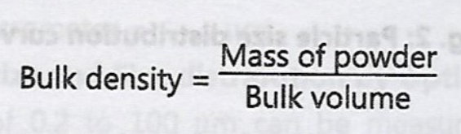

When the particles are packed loosely, lots of gaps between particles are observed. So, the bulk volume increases making the powder light. Based on bulk volume, powders are Classified as ‘light’ and ‘heavy’. Light powders have high bulk volume and heavy powder have low bulk volume. The bulk density depends on particle size distribution, shape and cohesiveness of particles.

**Requirement:**

**Chemical:** Powder Sample.

**Apparatus:** Bulk density apparatus, digital balance.

**Procedures:**

1. Weigh about 20 g of powder accurately using digital balance.

2. The powder is passing through Sieve No. 20.

3. About 20 g of powder carefully transfer into a graduated measuring cylinder which

is fixed on the bulk density apparatus.

4 The time knob is set for 100 taping.

5. The volume occupied by the powder is noted.

6. 50 tap may be continued and the final volume is noted.

7. The bulk density is calculated using the above equation.

**Observation and Calculation:**

Weight of powder = W g

Volume of powder = V cc

The bulk density = W/V

**Report:**

The bulk density of the given sample is ...... g/cc.

**Experiment No.-2**

**Determination of the Angle of Repose and influence of Lubricant on Angle of Repose**

**Aim:** To determine the angle of repose of a given sample (powder) and to check the

influence of lubricant (calcium stearate)

**Theory:**

The flow characteristics are measured by angle of repose. It is defined as the maximum angle possible between the surface of a pile of the powder and the horizontal plane. The flow of powder and the angle of repose is

tan®@=h/r or 6= tan‘ h/r

where, h = Height of pile

r = Radius of the base of the pile.

8 = Angle of repose

The angle of repose in pharmaceuticals refers to the maximum angle at which powdered drugs can be piled without collapsing. It is a critical parameter affecting the flow properties and handling of powders in formulation processes. The angle is influenced by factors such as particle size, shape, surface texture, and moisture content.

A higher angle of repose indicates poorer flowability, which can lead to issues in processes like mixing, tablet formation, and packaging. Conversely, a lower angle suggests better flow characteristics, facilitating uniform blending and consistent dosages.

Measuring the angle of repose helps pharmaceutical scientists optimize formulations and ensure that powders behave predictably during manufacturing. Understanding this property is essential for ensuring quality control and efficiency in production, impacting the overall effectiveness and stability of the final drug product.

|  |  |
| --- | --- |
| **Angle of repose in** | **Types of flow** |
| $$<25$$ | Excellent |
| 25-30 | Good |
| 30-40 | Passable |
| $$>40$$ | Very poor |

**Requirements:**

**Chemicals:** Powder Sample, Calcium Stearate.

**Apparatus:** Lab jak for lifting up and down, Glass funnel, Clamp having ring support, Scale, Capillary tube.

**Procedure:**

1. A glass funnel is held in place with a clamp on a ring support over a glass plate.

2. The glass plate is placed on a micro-lab jack.

3. Weigh 100 g of powder using digital balance.

4. Powder is passing through a 10 number mesh sieve.

5. Add different concentration of lubricant into the powder.

6. Keep the orifice of the funnel blocked by the thumb.

7. As the thumb is removed, the lab-jack is adjusted so as to lower the plate and

maintain about a 6.4 mm gap between the bottom of the funnel stem and the top of

the powder pile.

8. The height of the pile (h) and the radius of the base (r) are measured with the ruler.

9. Using the formula the angle of repose is measured.

**Observation & Calculation**

|  |  |  |  |  |  |  |  |
| --- | --- | --- | --- | --- | --- | --- | --- |
| No. of observation | Amount of lubricant | Height of heap(cm) | Average height in (cm) | Radius of the base of the cone | Average radius of the base of the cone (cm) | tan |  |
| 1 |  |  |  |  |  |  |  |
| 2 |  |  |  |  |  |  |  |
| 3 |  |  |  |  |  |  |  |

**Report:**

The angle of repose of the given sample is ---------°C.

**EXPERIMENT No.-3**

**Determination of Viscosity of Liquid using Ostwaild’s Viscometer**

**Aim:** To determine the viscosity of a supplied liquid (Newtonian liquid) sample using Ostwald’s viscometer or Ostwald ‘U’ tube viscometer or capillary viscometer.

**Theory:**

The viscosity of a fluid is a measure of its resistance to gradual deformation by shear

stress or tensile stress. For liquids, it corresponds to the informal concept of "thickness": for

example, honey has a much higher viscosity than water. For measuring the viscosity

co-efficient, Ostwald viscometer method is used. It is based on Poiseuille’s law, according to

this law, the rate of flow of a liquid through the capillary tube, having viscosity co-efficient. It can be expressed as:

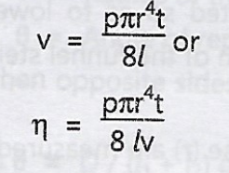

Where, v = Voiume of the liquid (in ml)

t = Flow of time (in sec) through capillary

r = Radius of the capillary (in cm)

l= Length of the capillary (in cm)

p = Hydrostatic pressure (in dyne/sq cm)

n = Viscosity co-efficient (in poise)

For a given Ostwald viscometer, the radius, length and volume of the liquid are constants and may be combined into a single constant K. So the above equation will be

n=Ktp

The pressure head ‘p’ depends on the density (p) of the liquid being measured, the acceleration due to gravity (g) and the difference in heights of the liquid arms of the

viscometer.

The acceleration due to gravity is a constant, capillary tube can be made constant by taking accurately measured identical volume of all liquids.

So, the equation will be



where, K’ is the constant of the viscometer. The constant can be determined using a liquid of known viscosities of known liquid. Viscosities of the unknown (n,) and (n,) liquids can be expressed by the following equations

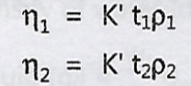

Combining the two above equations:



Using the above equation the relative and absolute viscosities of liquids are estimated. In the Newtonian system, the rate of shear is directly proportional to the shearing stress. Therefore, single point viscometer i.e. the equipment that works at a single rate of shear, is sufficient. The following viscometers are used:

(a) Capillary Viscometer

(b) Falling sphere Viscometer

In the cases of non-Newtonian fluids, multipoint viscometers are required, because the apparent viscosity is to be determined at a several of rates of shear to get entire consistency curve. Multipoint viscometer can also be used to determine the viscosity of Newtonian fluids, when maintained at constant rate of shear. The following viscometers are used:

(a) Cup and Bob viscometer

(b) Cone and Plate viscometer.

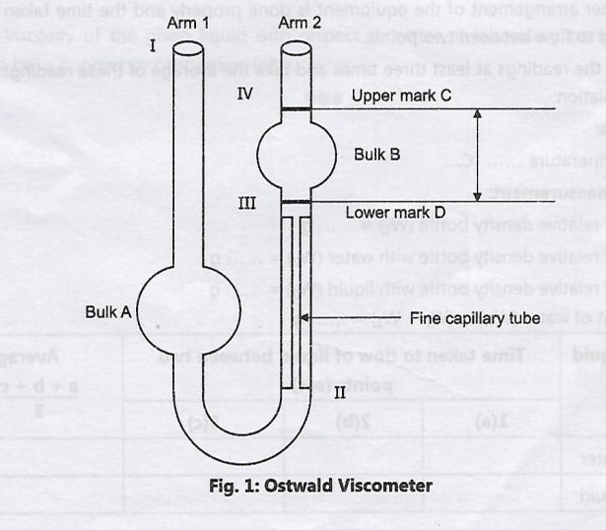

**Procedure:**

1.Thoroughly clean the viscometer.

2.After cleaning the viscometer dry it completely by using oven or passing current of air.

3.Place the viscometer on the stand vertically.

4.Take the weight of the empty and filled (with distilled water) relative density bottle

(with stopper). Then weigh the relative density bottle filled with unknown given

liquid. Use the data for measuring the densities.

5.Fill the purified water in the viscometer.

6.Report the time taken to flow water between two points.

7.Repeat the readings at least three times carefully and take the average of these readings for calculations.

8. Now, remove the water from viscometer and rinse with the unknown liquid under investigation 2-3 times and then fill the liquid in the same way as purified water.

9. Further arrangement of the equipment is done properly and the time taken for the liquid to flow between two points.

10.Take the readings at least three times and take the average of these readings for the

Calculation.

**EXPERIMENT No.-4**

**Determination of Effect of Different Suspending Agents on Sedimentation Volume**

**AIM:**  
To determine the effect of different suspending agents on the sedimentation volume of a suspension.

**Theory:**  
Suspension is a heterogeneous mixture where solid particles are dispersed in a liquid. The suspending agent is a substance that helps prevent the particles from settling quickly by stabilizing the suspension. The sedimentation volume is the ratio of the volume of sediment to the original volume of the suspension. Different suspending agents affect this volume by altering the viscosity and stability of the suspension.

**Reference:**

* Bingham, E. C. (1922). "Fluidity and Plasticity," McGraw-Hill.
* Fierer, J. S. (2002). "Pharmaceutical Suspensions," *Pharmaceutical Research*, 19(8), 1224-1230.

**Requirement:**

* Suspensions (e.g., kaolin, bentonite, starch, etc.)
* Stoppage jar
* Ruler
* Suspending agents (e.g., bentonite, tragacanth, etc.)
* Distilled water

**Procedure:**

1. Prepare a suspension of a solid in distilled water.
2. Add different suspending agents (e.g., bentonite, tragacanth) at a specified concentration to different samples of the suspension.
3. Stir each suspension thoroughly.
4. Pour the suspensions into separate graduated cylinders.
5. Allow the suspensions to settle for a fixed period (e.g., 24 hours).
6. Measure the sedimentation volume by calculating the ratio of the sediment to the total volume.

**Observation:**

* Measure the height of the sediment and note the total volume of the suspension.
* Observe which suspending agent yields the highest sedimentation volume.

**Calculation:**  
Sedimentation Volume = (Volume of sediment / Total volume of suspension) × 100%

**Result:**

* Tabulate the sedimentation volumes for suspensions with different agents.
* Compare the stability provided by each suspending agent based on the sedimentation volume.

**EXPERIMENT No.-5**

**Determination of Effect of Different Concentrations of a Single Suspending Agent on Sedimentation Volume**

**AIM:**  
To determine the effect of varying concentrations of a single suspending agent on the sedimentation volume.

**Theory:**  
Increasing the concentration of a suspending agent generally improves the viscosity of the suspension, thereby reducing the rate of sedimentation. The sedimentation volume can be used to assess the stability of the suspension with varying concentrations of the suspending agent.

**Reference:**

* Martin, A. (1993). "Physical Pharmacy," Lippincott Williams & Wilkins.

**Requirement:**

* A suspending agent (e.g., bentonite or tragacanth)
* Graduated cylinders
* Suspension material (e.g., kaolin)
* Distilled water
* Stirring rods

**Procedure:**

1. Prepare suspensions with varying concentrations of a single suspending agent (e.g., 0.5%, 1%, 2%, 3%).
2. Mix each suspension thoroughly.
3. Pour each suspension into separate graduated cylinders.
4. Let them settle for a fixed time (e.g., 24 hours).
5. Measure the sedimentation volume for each suspension.

**Observation:**

* Note any differences in the sedimentation volumes as the concentration of the suspending agent changes.

**Calculation:**  
Sedimentation Volume = (Volume of sediment / Total volume of suspension) × 100%

**Result:**

* Tabulate sedimentation volumes for suspensions with different concentrations of the suspending agent.
* Discuss the effect of concentration on suspension stability.

**EXPERIMENT No.-6**

**Determination of Particle Size and Particle Size Distribution Using Sieving Method**

**AIM:**  
To determine the particle size and particle size distribution of a sample using the sieving method.

**Theory:**  
Sieving is a mechanical process used to separate particles based on their size by passing them through a series of sieves with different mesh sizes. The distribution of particles is determined by measuring the amount of material retained on each sieve.

**Reference:**

* ASTM D421-85: "Standard Practice for Dry Preparation of Soil Samples for Particle-Size Analysis and Determination of Soil Constants."

**Requirement:**

* Sieves (with different mesh sizes)
* Sieve shaker
* Balance
* Sample of material to be analyzed

**Procedure:**

1. Select a series of sieves with appropriate mesh sizes (e.g., 250 μm, 500 μm, 1000 μm).
2. Weigh the sample to be analyzed.
3. Place the sieves in order, with the largest mesh at the top.
4. Place the sample on the top sieve and operate the sieve shaker for a specified time.
5. Weigh the material retained on each sieve.
6. Calculate the percentage of material on each sieve.

**Observation:**

* Record the weight of material retained on each sieve.
* Observe the distribution of particle sizes across the sieves.

**Calculation:**

* Percentage of material retained on each sieve = (Weight of material on sieve / Total weight of sample) × 100%

**Result:**

* Prepare a table showing the percentage of material retained on each sieve.
* Construct a particle size distribution curve.

**EXPERIMENT No.-7**

**Determination of Particle Size and Particle Size Distribution Using Microscopic Method**

**AIM:**  
To determine the particle size and distribution of a sample using a microscope.

**Theory:**  
The microscopic method involves directly observing the particles under a microscope and measuring their dimensions. Image analysis software can be used to analyze the particle size distribution by counting and measuring particles.

**Reference:**

* Jain, P. (2009). "Microscopic Methods for Particle Size Analysis."

**Requirement:**

* Microscope with a calibrated scale
* Sample to be analyzed
* Image analysis software (optional)

**Procedure:**

1. Prepare a dilute suspension of the sample in a suitable medium.
2. Place a drop of the suspension on a microscope slide.
3. Observe the sample under a microscope.
4. Measure the sizes of individual particles (using a calibrated scale or image analysis software).
5. Record the particle sizes and count the number of particles in different size ranges.

**Observation:**

* Note the particle sizes and distribution.
* Record the number of particles within different size categories.

**Calculation:**

* Calculate the average particle size:



**Result:**

* Present the particle size distribution and average particle size.
* Construct a histogram of the particle sizes.

**EXPERIMENT No.-8**

**Determination of Surface Tension of Given Liquid by Drop Count Method Using Stalagmometer**

**AIM:**  
To determine the surface tension of a given liquid using the drop count method.

**Theory:**  
The surface tension of a liquid is defined as the force per unit length acting on the surface of the liquid. The drop count method involves counting the number of drops formed when a liquid is allowed to fall from a stalagmometer.

**Reference:**

* Bansal, M. (2009). "Pharmaceutical Formulations," Springer.

**Requirement:**

* Stalagmometer
* Distilled water
* Given liquid (e.g., organic solvent or solution)
* Thermometer
* Balance

**Procedure:**

1. Fill the stalagmometer with the liquid whose surface tension is to be measured.
2. Count the number of drops of liquid that fall from the stalagmometer over a known time period.
3. Repeat the measurement at least three times for accuracy.
4. Record the temperature and use it to calculate the surface tension.

**Observation:**

* Note the number of drops and the temperature of the liquid.

**Calculation:**

**Result:**

* Present the surface tension of the given liquid.

**EXPERIMENT No.-9**

**Determination of Surface Tension of Given Liquid by Drop Weight Method Using Stalagmometer**

**AIM:**  
To determine the surface tension of a given liquid using the drop weight method.

**Theory:**  
In the drop weight method, the weight of a single drop of liquid is used to calculate the surface tension. The relationship between the weight of a drop and the surface tension can be derived from the formula for drop formation.

**Reference:**

* Arora, S. (2012). "Chemical Engineering Principles," Wiley.

**Requirement:**

* Stalagmometer
* Distilled water
* Liquid to be tested
* Balance
* Thermometer

**Procedure:**

1. Attach the stalagmometer to a vertical support.
2. Fill the stalagmometer with the liquid.
3. Measure the weight of each drop by collecting drops onto a balance.
4. Determine the number of drops per unit mass.

**Observation:**

* Record the weight of individual drops and the number of drops.

**Calculation:**  
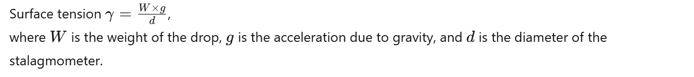

**Result:**

* Calculate and present the surface tension of the given liquid.

**EXPERIMENT No.-10**

**Determination of CMC of Surfactant (Sodium Lauryl Sulphate) Following Surface Tension Measurement**

**AIM:**  
To determine the critical micelle concentration (CMC) of sodium lauryl sulfate using surface tension measurements.

**Theory:**  
The CMC is the concentration of surfactant above which micelles are formed, and any further increase in surfactant concentration does not affect the surface tension. By measuring the surface tension at different concentrations of the surfactant, the CMC can be determined.

**Reference:**

* Rosen, M. J. (2004). "Surfactants and Interfacial Phenomena," Wiley-Interscience.

**Requirement:**

* Sodium lauryl sulfate solution
* Distilled water
* Stalagmometer
* Balance

**Procedure:**

1. Prepare solutions of sodium lauryl sulfate at different concentrations.
2. Measure the surface tension of each solution using the drop weight method or stalagmometer.
3. Plot the surface tension against the concentration.
4. Identify the concentration at which the surface tension stops decreasing significantly; this is the CMC.

**Observation:**

* Record surface tension values for different concentrations of the surfactant.

**Calculation:**  
CMC is identified at the point where surface tension becomes constant.

**Result:**

* Report the CMC of sodium lauryl sulfate.

**EXPERIMENT No.-11**

**Determination of Reaction Rate Constant (First Order)**

**AIM:**  
To determine the rate constant for a first-order reaction.

**Theory:**  
In a first-order reaction, the rate is directly proportional to the concentration of one reactant. The integrated rate law for a first-order reaction is:

**Reference:**

* Laidler, K. J. (1987). "Chemical Kinetics," HarperCollins.

**Requirement:**

* Reactants for a first-order reaction (e.g., hydrolysis of ester)
* Spectrophotometer or titration setup
* Timer

**Procedure:**

**Observation:**

* Measure and record the concentration of the reactant at different times.

**Calculation:**  


**Result:**



**EXPERIMENT No.-12**

**Determination of Reaction Rate Constant (Second Order)**

**AIM:**  
To determine the rate constant for a second-order reaction.

**Theory:**  
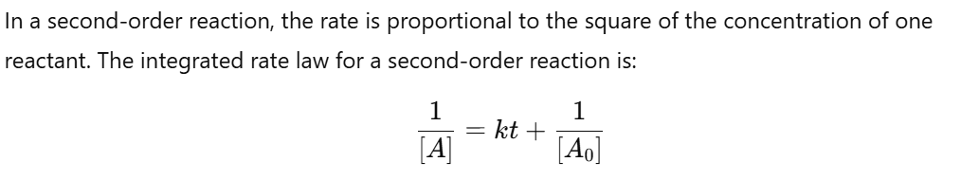

**Reference:**

* Atkins, P. (2006). "Physical Chemistry," Oxford University Press.

**Requirement:**

* Reactants for a second-order reaction (e.g., iodine clock reaction)
* Spectrophotometer or titration setup
* Timer

**Procedure:**

**Observation:**

* Measure and record the concentration of the reactant at different times.

**Calculation:**  


**Result:**

